Foreign Minister Retno: Southeast Asian Region Must Remain Free of Nuclear Weapons

Jakarta, 11 July 2023. Indonesian Minister of Foreign Affairs Retno Marsudi stated that Southeast Asia must remain a region free of nuclear weapons. Foreign Minister Retno conveyed this statement when chairing the Meeting of the Commission of the Southeast Asia Nuclear Weapon Free Zone (SEANWFZ) on Tuesday (11/7) in Jakarta.

During the meeting, Retno said the risk of using nuclear weapons use is higher today than at any time in recent history. She adds: "Southeast Asia is still not a truly safe region as long as there are countries that have nuclear weapons".

Retno also expressed disappointment with countries that still adhere to military doctrines based on nuclear weapons in the Southeast Asian region. With nuclear weapons, one miscalculation can trigger a global disaster.

"The maintenance of peace and stability in the region is our priority. It is our foundation to turn the region into the Epicentrum of Growth. Therefore, we must keep Southeast Asia as a region free of nuclear weapons," Foreign Minister Retno said.

The SEANWFZ Treaty has contributed to global disarmament efforts and the non-proliferation regime. However, over the past 25 years, no nuclear weapon state has signed the SEANWFZ Treaty Protocol.

Together with other ASEAN Foreign Ministers, the Indonesian Foreign Minister called for nuclear weapon states to immediately sign the SEANWFZ Treaty Protocol.

Previously, in 2022, the SEANWFZ Commission had agreed to explore the option for nuclear weapon states to sign the SEANWFZ Treaty Protocol first, as long as they are committed to this protocol.

"We must unite to create a path towards a nuclear weapon-free region," Retno said.

In Indonesia's national statement, Retno raised the ratification of the SEANWFZ Treaty Protocol by nuclear weapon states and the importance of the SEANWFZ Treaty Biennial Resolution.

During the meeting, ASEAN Foreign Ministers affirmed the political will to urge nuclear weapon states to accede to the SEANWFZ Treaty Protocol. The meeting also discussed the implementation of the SEANWFZ Treaty Protocol action plan review. In addition, the foreign ministers agreed to assign a working group to discuss this issue further. The meeting also successfully adopted a Concept Note on the Possible Joint Initiatives of OPANAL and ASEAN in 2023.

***

For further information, please contact the following:

Director for Information and Media of the Ministry of Foreign Affairs - Hartyo Harkomoyo (+62811831899).

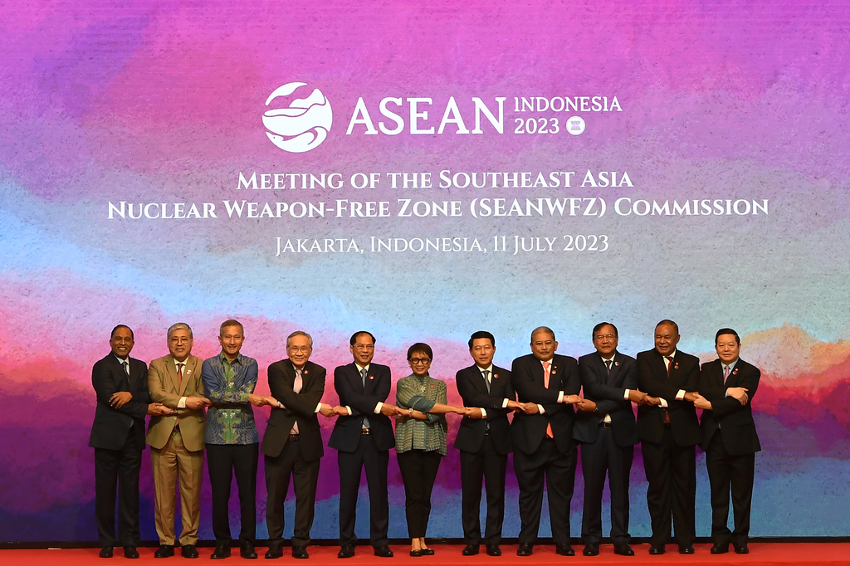

Indonesian Minister of Foreign Affairs Retno Marsudi stated that Southeast Asia must remain a region free of nuclear weapons when chairing the Meeting of the Commission of the Southeast Asia Nuclear Weapon Free Zone (SEANWFZ) on Tuesday (11/7) in Jakarta.

